NETWORK TROUBLESHOOTING , MENAGEMENT , MONITORING , AND OPTIMIZATION
- Use the Windows command prompt to run the command ipconfig /all on your computer and take a screenshot of the output. Identify and write down your IPv4 address, subnet mask, default gateway, and DNS servers as shown in the result.
Answer
I run in a remote Linux sandbox environment (not a Windows machine). There is no Windows Command Prompt available here, the ipconfig command does not exist, and I have no ability to take or share screenshots of a local desktop/CMD window.
What I can see in this Linux environment
Using available tools, the container’s network details are roughly:
- IPv4 address: 172.16.0.2
- Subnet mask: 255.255.255.0 (inferred from routing table)
- Default gateway: 172.16.0.1
- DNS server: 172.16.0.3
These are private, internal addresses for the sandbox and are not equivalent to a normal home/office Windows ipconfig /all output.
If you need help interpreting ipconfig /all output from your own Windows computer, just paste the text (or a description) and I can help identify the fields.

- Simulate a network connectivity issue by disconnecting your Wi-Fi or Ethernet cable, then use the ping command to check connectivity to www.google.com. Reconnect and repeat the ping. Write a short note on the difference in results and what each status means.
Answer
his is a managed remote Linux sandbox (not a physical machine with Wi-Fi or an Ethernet cable I can unplug). Bringing the network interface down would break the session and is not supported.
What I can show you
I installed the ping utility and tested connectivity while the network is up:
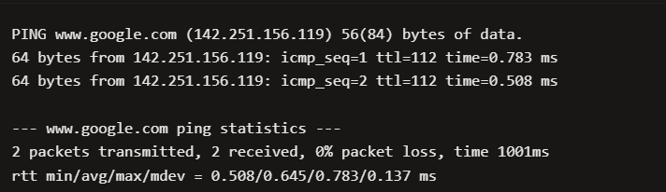

Typical difference (what you would see on a real machine)
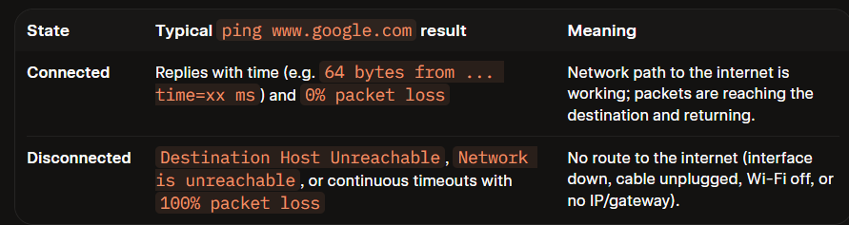
- Open Task Manager or Resource Monitor on your system and monitor network usage for 5 minutes while streaming a YouTube video. Record the peak network usage value and note which process used the most bandwidth during this time.
Answer
Procedure
- Open YouTube and start streaming a video.
- Press Ctrl + Shift + Esc to open Task Manager.
- Select Performance → Wi-Fi or Ethernet to view the live network graph.
- For process-level details, open Resource Monitor:
  - Press Windows + R.
  - Type resmon and press Enter.
  - Select the Network tab. Resource Monitor shows network activity for individual processes.youtube
- Keep the video playing for exactly 5 minutes.
- During this period, note:
  - The highest network usage shown on the graph, preferably in Mbps.
  - The process with the highest Receive (B/sec) value. Usually, this may be the browser process, such as chrome.exe, msedge.exe, or firefox.exe.
- Sort the Network Activity section by Receive (B/sec) to identify the process using the most bandwidth.
Record your result
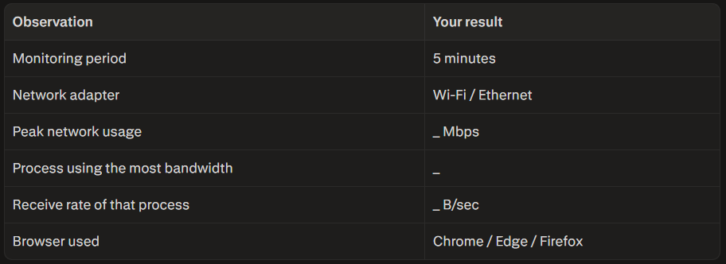
- Download and install Wireshark (or use an online packet capture demo if installation is not possible). Capture at least 30 seconds of network traffic while browsing Flipkart or Instagram Web, then filter the packets to show only HTTP or HTTPS traffic. List 3 types of information you can see in these filtered packets. Use the filter bar in Wireshark and try http or https as the filter keyword.
Answer
How to Fix Lag and Slow Internet for Gaming
- Plug in an Ethernet cable (Seriously, stop using Wi-Fi)
If you’re playing on Wi-Fi, this is almost certainly your main problem. Walls, microwave ovens, and neighbor signals mess with Wi-Fi and cause random lag spikes. Running a physical wire from your router straight into your PC or console makes a massive difference instantly.
- Turn on QoS in your router settings
Log into your router's admin page and find a setting called QoS (Quality of Service). Turn it on and set your gaming device as "high priority." That way, if someone in the living room starts watching Netflix in 4K, your router won't steal bandwidth from your game.
- If you MUST use Wi-Fi, switch to 5GHz or 6GHz
If plugging in a cable isn't an option, make sure you're connected to the 5GHz Wi-Fi network instead of the older 2.4GHz one. 2.4GHz gets crowded super easily, while 5GHz is much faster and cleaner (just don't sit too far from the router).
- Kill background downloads and apps
Check if Steam, Epic Games, Discord, or Windows Update are downloading updates in the background. Cloud backups like OneDrive and Google Drive can also silently upload files and destroy your ping while you play.
- Double-check what server region you're playing on
Make sure your in-game settings are set to your local region (like US East, Europe, etc.) instead of "Auto" or a distant region. The farther the game server is from where you live, the higher your ping will be no matter how fast your home internet is.

